sudo apt install wget
sudo wget https://download.oracle.com/java/21/latest/jdk-21_linux-x64_bin.tar.gz
tar -xzf jdk-21_linux-x64_bin.tar.gz
sudo mv jdk-21.0.5 /usr/lib/jvm/
sudo vim /etc/profile
Scroll to the end of the file and add the following lines, adjusting the JAVA_HOME path to match your JDK installation directory:
export JAVA_HOME=/usr/lib/jvm/jdk-21.0.5
export PATH=$JAVA_HOME/bin:$PATH
To apply the changes made to /etc/profile, you need to either reboot the system or run:

source /etc/profile
java -version

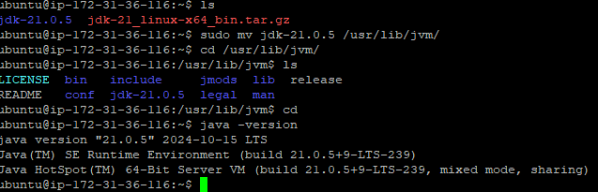
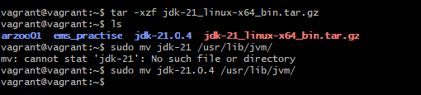

-----

ELASTICSERACH INSTALLATION

cd /opt/
sudo mkdir prod testing
sudo wget https://artifacts.elastic.co/downloads/elasticsearch/elasticsearch-8.15.0-linux-x86_64.tar.gz

sudo tar -xvf elasticsearch-8.15.0-linux-x86_64.tar.gz

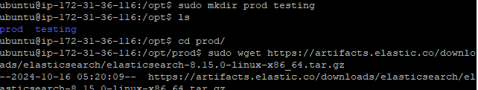
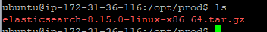
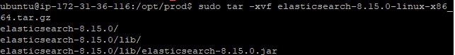

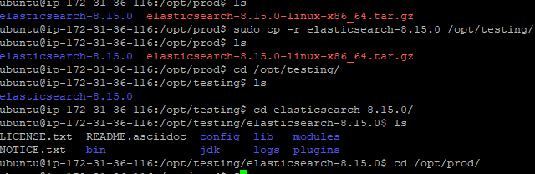

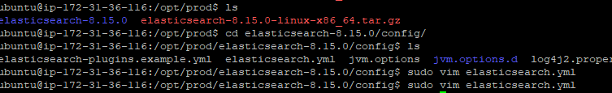
enable port 9200
enable network port 0.0.0.0
enable clustername
enable node name
/opt/prod/elasticsearch-8.15.0/logs

find / -name elasticsearch 2>/dev/null
sudo vim /etc/systemd/system/elasticsearch-prod.service

[Unit]
Description=Elasticsearch Production
After=network.target

[Service]
Type=simple
User=elasticsearch
Environment=ES_JAVA_OPTS="-Xms1g -Xmx1g"
Environment=JAVA_HOME=/usr/lib/jvm/jdk-21.0.5
ExecStart=/opt/prod/elasticsearch-8.15.0/bin/elasticsearch

Restart=on-failure
[Install]
WantedBy=multi-user.target

sudo chown -R elasticsearch:elasticsearch /opt/prod/elasticsearch-8.15.0
sudo chmod +x /opt/prod/elasticsearch-8.15.0/bin/elasticsearch

sudo systemctl daemon-reload
sudo systemctl start elasticsearch-prod
sudo systemctl status elasticsearch-prod

Sudo ufw status
sudo ufw enable
sudo ufe allow 9200
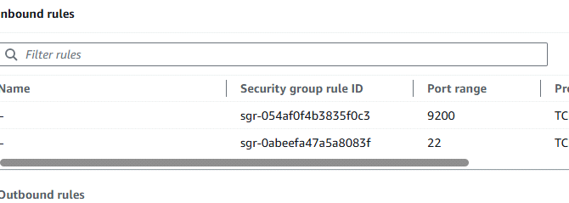
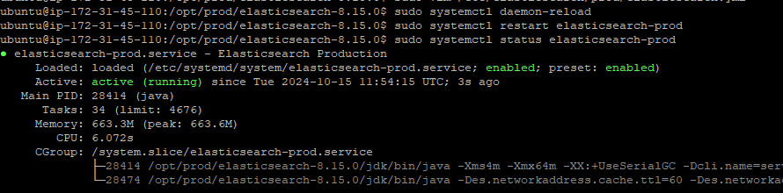
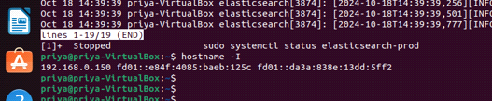

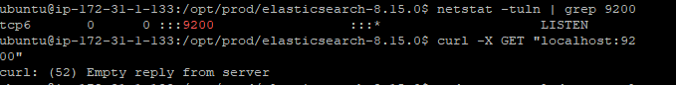

when we connect in the browser with ipaddress:portnumber


IF WE ADD HTTPS BEFOR IP https://ip:9000
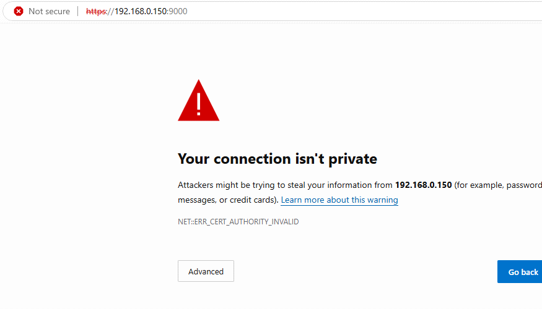

Click on advanced ,and clic on continue to

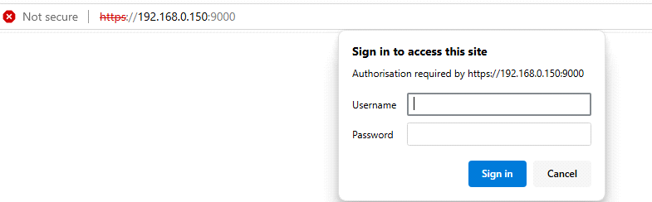

Here username is elastic,for password we need to run this command
sudo /opt/prod/elasticsearch-8.15.0/bin/elasticsearch-reset-password -u elastic

PASSWORD
sudo /opt/prod/elasticsearch-8.15.0/bin/elasticsearch-reset-password -u elastic
ykwq3rA83zFoVGn2MS-y
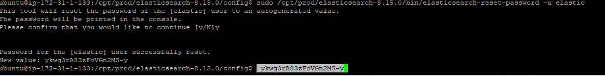
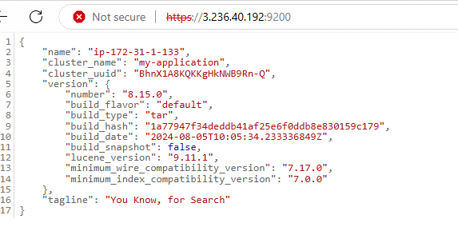

without asking password and without entering https how can connect to that
we have to change the configuration in elasticsearch.yml file
# Enable security features
xpack.security.enabled: false

xpack.security.enrollment.enabled: false

# Enable encryption for HTTP API client connections, such as Kibana, Logstash, and Agents
xpack.security.http.ssl:
enabled: true
keystore.path: certs/http.p12

# Enable encryption and mutual authentication between cluster nodes
xpack.security.transport.ssl:
enabled: false
verification_mode: certificate
keystore.path: certs/transport.p12
truststore.path: certs/transport.p12
# Create a new cluster with the current node only
# Additional nodes can still join the cluster later
cluster.initial_master_nodes: ["node-1"]

o/p
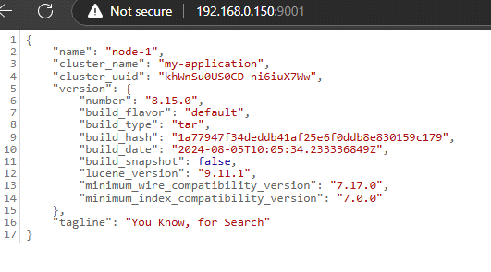

**********************************
IN THE SAME FOR TESTING ENV
cd /opt
mkdir testing
cd testing
cp -r /opt/prod/elastisearch-8.15.0/ /opt/testing/elastic.....
cd elasti.....
cd confif
sudo vim elastisearch.yml
modify the file
clustername..
node..
network ip
port..# Enable security features
xpack.security.enabled: false

xpack.security.enrollment.enabled: false

# Enable encryption for HTTP API client connections, such as Kibana, Logstash, and Agents
xpack.security.http.ssl:
enabled: true
keystore.path: certs/http.p12

# Enable encryption and mutual authentication between cluster nodes
xpack.security.transport.ssl:
enabled: false
verification_mode: certificate
keystore.path: certs/transport.p12
truststore.path: certs/transport.p12
# Create a new cluster with the current node only
# Additional nodes can still join the cluster later
cluster.initial_master_nodes: ["node-1"]

after that add the elasticsearch-testing.servicefile
sudo vim /etc/systemd/system/elasticsearch-testing.service

[Unit]
Description=Elasticsearch testing
After=network.target

[Service]
Type=simple
User=elasticsearch
Environment=ES_JAVA_OPTS="-Xms1g -Xmx1g"
Environment=JAVA_HOME=/usr/lib/jvm/jdk-21.0.5
ExecStart=/opt/testing/elasticsearch-8.15.0/bin/elasticsearch

Restart=on-failure
[Install]
WantedBy=multi-user.target

sudo chown -R elasticsearch:elasticsearch /opt/testing/elasticsearch-8.15.0
sudo chmod +x /opt/testing/elasticsearch-8.15.0/bin/elasticsearch

sudo ufw allow 9001
sudo ufw status

sudo systemctl daemon-reload
sudo systemctl start elasticsearch-testing
sudo systemctl status elasticsearch-testing

sudo netstat -tuln | grep 9000
curl -X GET "localhost:9000"

****************************************************************
******************************************************************

[[[[[[[[ not necessary
Create directories for each environment:
sudo mkdir -p /etc/elasticsearch/prod
sudo mkdir -p /etc/elasticsearch/test

sudo cp /etc/elasticsearch/elasticsearch.yml /etc/elasticsearch/prod/
sudo cp /etc/elasticsearch/elasticsearch.yml /etc/elasticsearch/test/]]]]]]]]]]]]]





